If the employee is only reporting an exposure or potential exposure, these are the steps to take in WebApps.
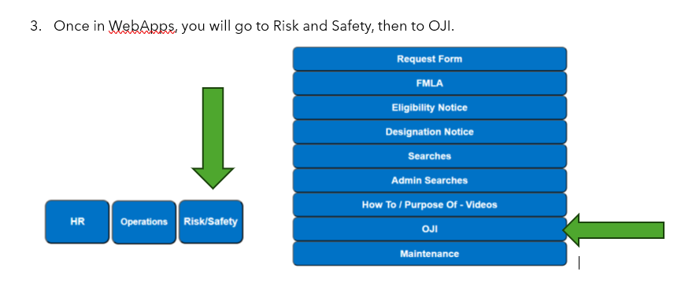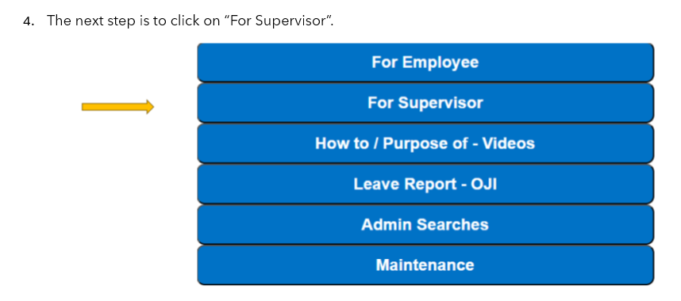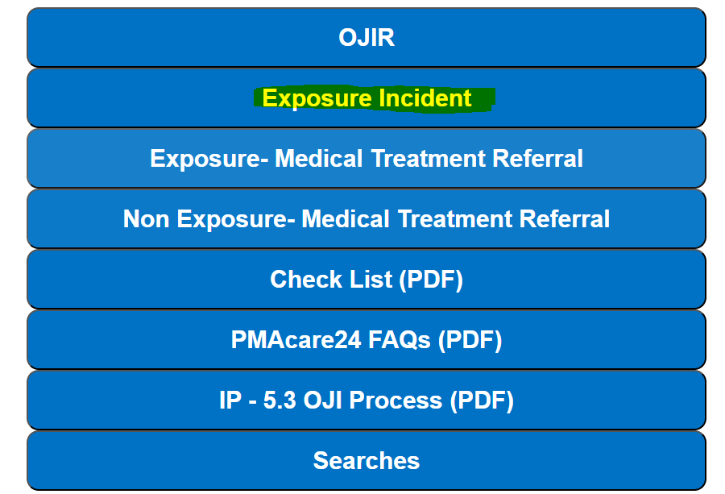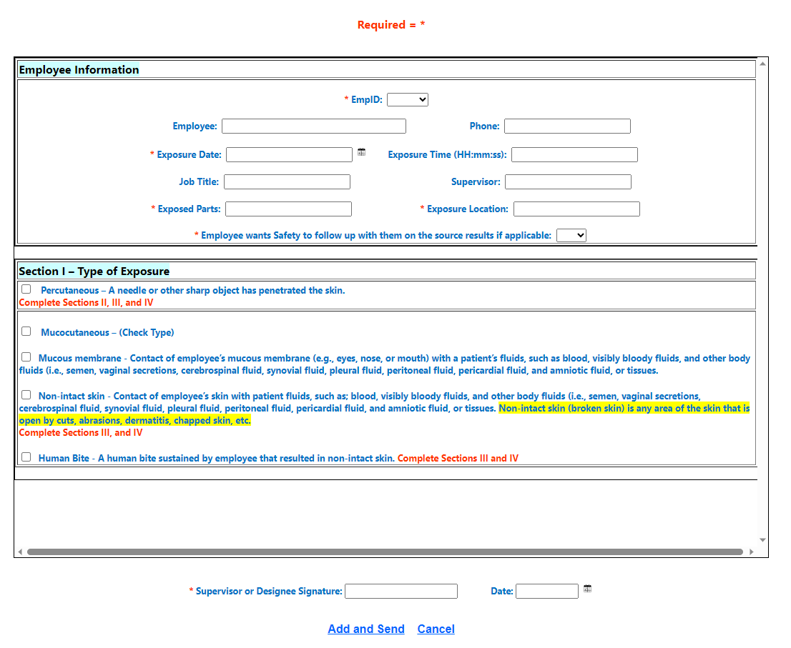Here is where I should have done a better job of explaining. You have 3 choices for Section 1 – Type of Exposure.
Include this if the employee does want medical care.
This is the only part you will need to complete if the employee does not want to be seen for medical care.
- Percutaneous – a needle or other sharp object penetrated the skin.
- Mucocutaneous – which is either,
  - Mucous Membrane – Contact of employee’s mucus membrane with a patient’s fluids. Or,
  - Non-intact skin – Contact of employee’s skin with patient fluids.
- Human Bite – This is a bite that resulted in non-intact skin of the employee.
Only 2 of these will prompt additional information to be added such as source patient data. The RED “Complete Sections II, III, and IV” or “Complete Sections III, and IV” indicate which type of exposure will result in additional information being required.
You may notice that #1, Percutaneous, requires sections II, III, and IV while #2 &#3 only require sections III and IV (see below). This is because a sharps injury requires us to document the sharps information for OSHA.
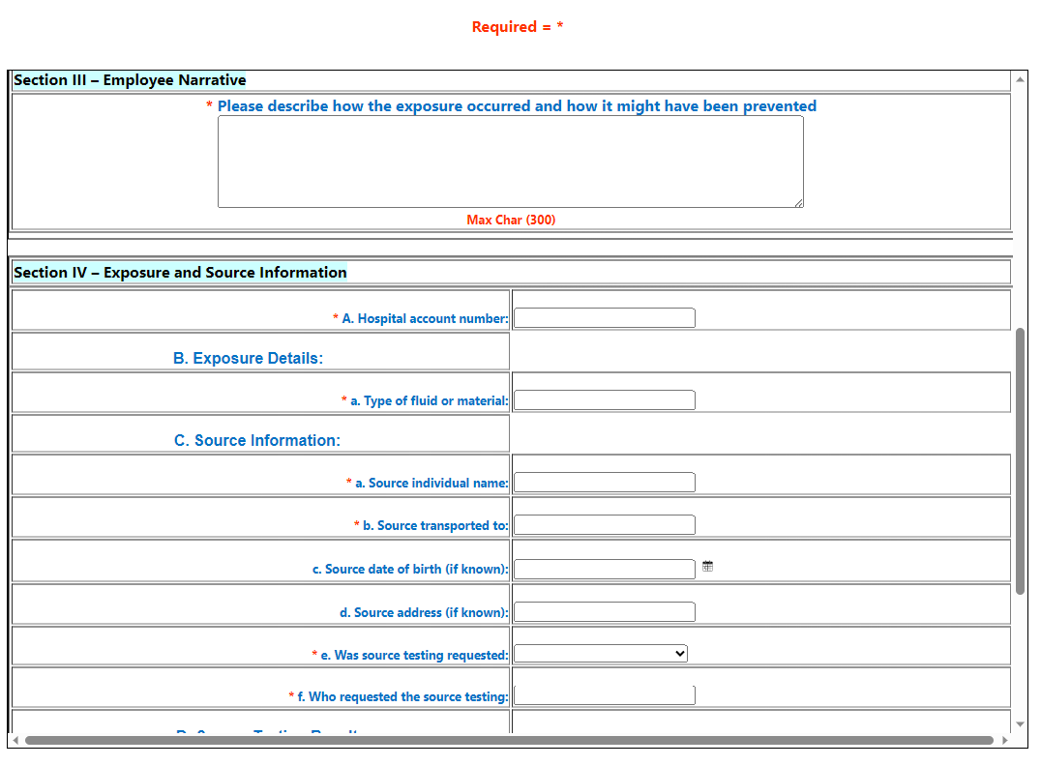

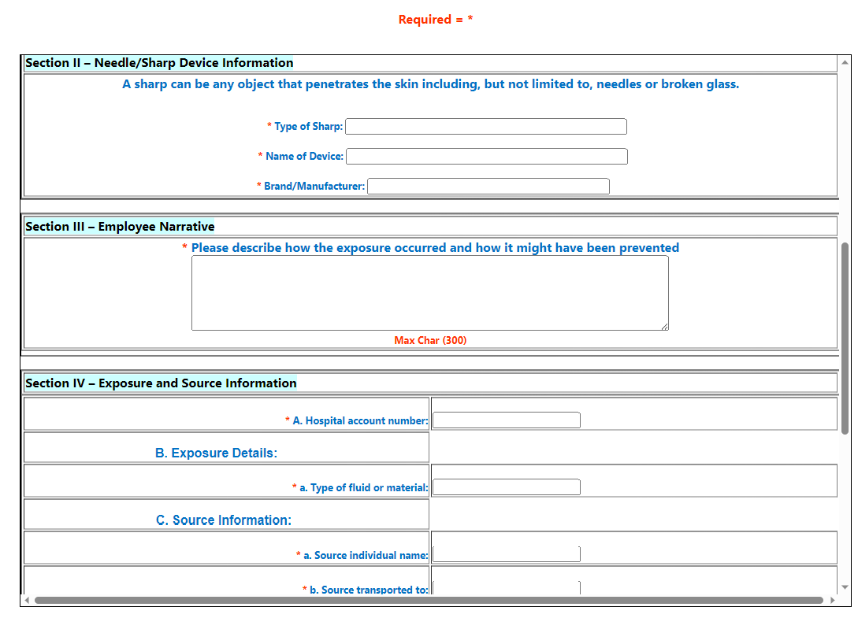
Regardless of the section you complete, don’t forget to finish it by clicking ADD and Send.
